Lab 4
Implementing a DMZ
Objective:
The purpose of this lab is for the student to understand basic features of and implement a DMZ. Students will also utilize IOS commands and a GUI to explore and configure a Cisco firewall.
Diagram:
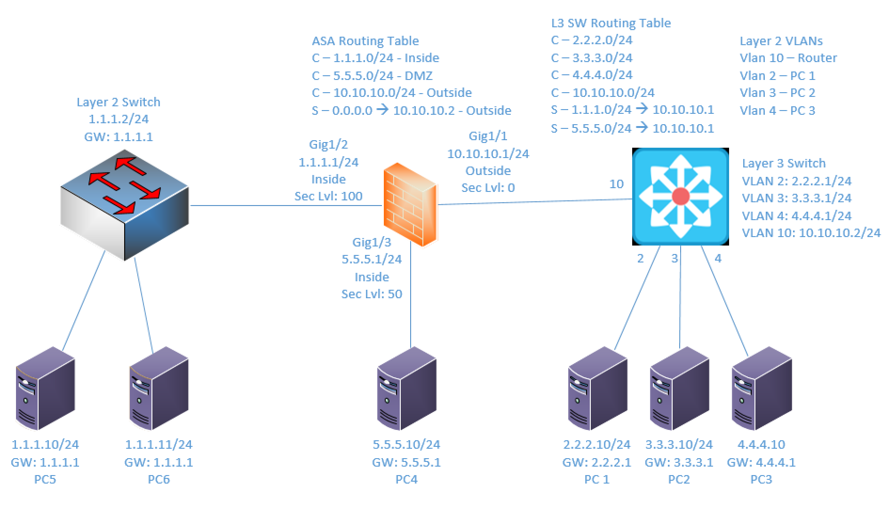
Components:
6 – PC’s
1 – Cisco 3650 Layer 3 Switch
1 – Cisco 3650 Layer 2 Switch
1 – Cisco 5516-X ASA Firewall

Useful commands for this lab:

show route – view ASA routing table
show interface ip brief – view status of ASA layer 3 interfaces
show nameif – view ASA interface names and security levels

Configure Firewall Interface

int gigabitethernet1/1
nameif outside
security-level 0
ip add 2.2.2.1 255.255.255.0
no shutdown

Configure Routes from CLI – NOTE: Must specify interface name

route outside 0.0.0.0 0.0.0.0 10.10.10.2

Create object from CLI:

object network internal-network
subnet 1.1.1.0 255.255.255.0

object network server1
host 1.1.1.10

object network server2
host 1.1.1.11

object-group network Internal_Servers
network-object object server1
network-object object server1

Procedure:
- Connect all PC’s together on the layer 3 switch and put their static IP addresses, subnet masks and gateways on them. Test connectivity by pinging each machine within the network.

- Using the diagram above, label the Layer 3 switches VLAN IP addresses and ports below
Layer 3 Switch
VLAN | IP | Switch Port
2 | 2.2.2.1/24 | 2
3 | 3.3.3.1/24 | 3
4 | 4.4.4.1/24 | 4
10 | 10.10.10.1/24 | 10

- Using the diagram above, label the routing tables for the Layer 3 switch and firewall below.
Firewall | Layer 3 Switch
C – 1.1.1.0/24 (inside) | C – 2.2.2.0/24
C – 5.5.5.0/24 (DMZ) | C – 3.3.3.0/24
C – 10.10.10.0/24 (outside) | C – 4.4.4.0/24
S – 0.0.0.0 -> 10.10.10.2 (outside) | C – 10.10.10.0/24
 | S – 1.1.1.0/24 -> 10.10.10.1
 | S – 5.5.5.0/24 -> 10.10.10.1

- Place the switch ports into the proper vlans. Configure all of the switches vlan IP addresses.
- Enable routing on the Layer 3 switch
- View the routing table on the Layer 3 switch
- Verify that the PCs on the L3 switch can ping each other.
- Verify that the PCs on the L2 switch can ping each other.

- Configure the IP addresses on the firewalls inside interface, set the name of the interface and the security level, and turn on the interface.
  - What commands did you enter?
Int gig1/1
Nameif outside
Security-level 0
Ip address 10.10.10.1 255.255.255.0

Int gig1/2
Nameif inside
Security-level 100
Ip address 1.1.1.1 255.255.255.0

Int gig1/3
Nameif dmz
Security-level 50
Ip address 5.5.5.1 255.255.255.0

- Ping the firewalls inside interface from a machine on the 1.1.1.0/24 network and verify it is up and working.

- Enable http access to the firewall and allow the 1.1.1.0/24 network to access it from the inside interface. Refer to the previous lab if needed.
  - What commands did you enter?

http server enable
http 1.1.1.10 255.255.255.0 inside
ssl server-version t1sv1.2
ssl client-version t1sv1.2
ssl cipver t1sv1.2 fips

- Connect to the firewalls GUI through the web browser.
- Select the configuration tab and under device setup select interfaces
- Create the Interfaces for the outside and DMZ networks.
  - List the interfaces details below:
Layer 3 Switch
Interface | IP | Security Level | Name
GigabitEthernet1/1 | 10.10.10.1/24 | 0 | Outside
GigabitEthernet1/2 | 1.1.1.1/24 | 100 | Inside
GigabitEthernet1/3 | 5.5.5.1/24 | 50 | DMZ

- Add the default route and select the outside interface.
- Select the firewall tab. Click on NAT Rules.
- Add a NAT rule that allows the 1.1.1.0/24 source to the outside destination and uses the firewall outside interface IP.
- Add a NAT rule that allows the 1.1.1.0/24 source to the dmz (5.5.5.0/24) network destination and uses the original IP addresses.
- Add a NAT rule that allows the 5.5.5.10 DMZ source to the outside destination and uses the IP 10.10.10.10.
- Under the firewall select Objects and then network objects/groups.
- Add all 3 external networks objects and create an External_Networks group.
- Add servers 1 and 2 objects and create an Internal_Servers group.
- Add the dmz server object and create a DMZ_Servers group
- Add a network Object group. Call the group name Web_Servers and add servers 1 and 2 to the group.
- Create a service group called Web_Services and add ICMP, http and https (tcp ports 80 and 443)

- Create a service group called Internal_Services and add SQL (TCP 1433) HTTP and HTTPS, and ICMP.

- Create an access-list and Allow the DMZ server to access the Internal Servers via the Internal Services object. Allow the DMZ server to send ICMP traffic to the outside Interface.

- Allow the outside networks to get to the DMZ server via the Web_Services object.

- Can the Outside devices ping the DMZ Server? Yes
  - Why? Because there’s an ACL saying allowing ICMP traffic from the outside network to the DMZ

- Can the Outside devices ping the Internal Servers? No
  - Why? There is no ACL allowing the outside network to send ICMP traffic to the internal network or servers

- Can the Internal Servers ping the Outside devices? Yes
  - Why? The inside server has a higher security level than the outside servers and NAT is set up to dynamically translate IPs

- Create a rule allowing ICMP echo reply traffic to flow from the Outside to the Inside servers.

- Can the Internal Servers ping the Outside devices? Yes
  - Why? Going from high to low security

- Can the Outside devices ping the Internal Servers? No
  - Why? Only ICMP echo is the only traffic allowed in, not ICMP ping requests

- What IP do the Outside devices see the DMZ Server? 10.10.10.10

- What IP do the Outside devices see Internal Server 1? 10.10.10.1

- What IP do the Outside devices see Internal Server 2? 10.10.10.1
  - Why? We set up a dynamic NAT that uses the outside network’s interface when traffic flows out from the inside network.

- Screen shot your objects and paste here:
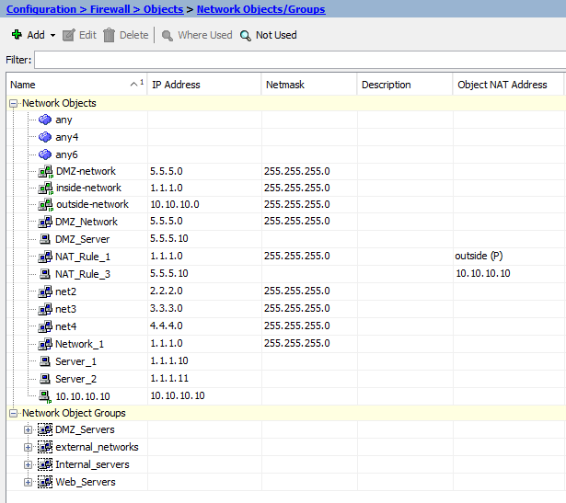
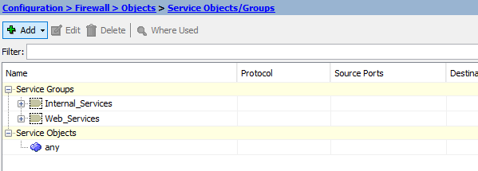
- Screen shot your access-lists and paste here:
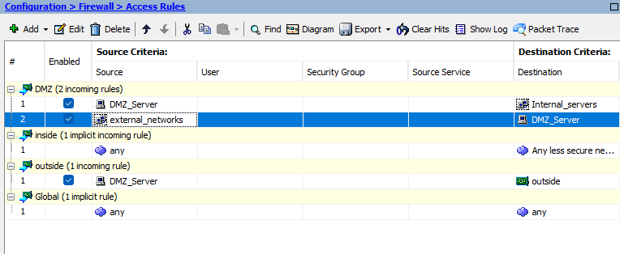
- Screen shot your Interfaces and paste here:
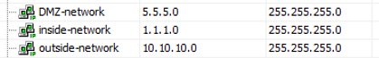
- Screen shot your NATs and paste here:
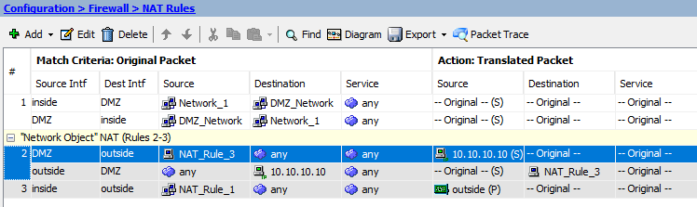

- Create the lab diagram below (PCs, router and switch connections) in Packet Tracer or Visio. Label the IP addresses, subnet masks, and gateways used by each device. Label the routing tables next to the switch and router and the switches vlan IP addresses and port vlan information. Add the Firewall Zones and NAT Translations
